- Installation of Linux OS using VM.

1. Once the installation of VirtualBox is complete, run VirtualBox from Start>Programs. You should get a screen like the following:
2. Click on New, and the New Virtual Machine Wizard should pop up and guide you through the process of creating a new virtual machine.
3. Click Next to start the process.
a. The first steps are to give your virtual machine a name and select the OS and version.
b. Type in a name for your machine (I recommend using a single word not a phrase).
c. Under Operating System: Choose Linux
d. Under Version, choose Ubuntu
e. Click Next
4. The next step is to select the amount of RAM for your virtual machine. The amount of memory given here will be taken away from your host machine and presented to the guest operating system, which will report this size as the (virtual) computer's installed RAM. 1024MB (1GB) is a good allocation for Ubuntu.

Note[1]: Choose this setting carefully! The memory you give to the VM will not be available to your host OS while the VM is running, so do not specify more than you can spare. For example, if your host machine has 1 GB of RAM and you enter 512 MB as the amount of RAM for a particular virtual machine, while that VM is running, you will only have 512 MB left for all the other software on your host. If you run two VMs at the same time, even more memory will be allocated for the second VM (which may not even be able to start if that memory is not available). On the other hand, you should specify as much as your guest OS (and your applications) will require to run properly.
[1] http://www.virtualbox.org/manual/ch01.html#intro-installing
5. The next step is to create/select a virtual hard-disk for your virtual machine.
a. If you are using an image from the lab, select that image file from the “Use existing hard disk” option.
b. Else, select Create New Hard disk and select Next/
6. Choose “dynamically expanding storage” as your type of hard disk, and click Next
7. The virtual hard-disk exists as a file on your host computer. Choose the location of where you want to store the hard-disk file. (Also choose the size.)
a. 10GB is a good size for Ubuntu
b. Make sure the location has 10GB to spare. The file will start out smaller (since we chose dynamically expanding storage, but can reach the full 10GB if you fill up your virtual machine).
c. When ready, click Next.
8. Click Finish if you are ready to create the disk. Or click Back if you want to change any settings.
9. You should now return to the Create Virtual Machine page. Which will present you a summary of the Virtual Machine to be create. Verify that all the data looks ok, and click Finish to complete creating the machine.
10. Congratulations! You just created your virtual machine. It is now ready to accept the installation of Ubuntu.
a. On your VirtualBox manager screen, you should now see the machine you just created listed.
11. Before we boot up this machine, we need to configure the CD drive.
a. This is to enable it to find the disc image (containing Ubuntu installation) so that it can to boot from this disc.

b. For this, select the machine you just created, and click the Settings button on the toolbar. You should see a screen like the following show up.

12. Select the “Storage” option on the left pane.
a. Now click on the single + symbol next to the entry “IDE Controller” under the entry Storage Tree.
13. When prompted to Add a New CD/DVD drive, choose “Choose Disk”

14. You will now be taken to choose the file to mount. Choose the ISO image containing Ubuntu, and click Open

15. The drive should now be mounted and will be listed under the storage tree.

16. Click OK and you’ll return to the Virtual Box Manager screen.

17. It is now time to boot up our machine and install the OS. Select the Ubuntu machine and click the START icon.
a. You should see the machine begin to boot and bring you to the Ubuntu install screen.

b. Choose Install Ubuntu to begin the installation process.

c. This is the typical Ubuntu installation process. Follow the prompts and let it install.

18. When you are done installing, the virtual machine will reboot and when you login, you should be presented with the Ubuntu login desktop.

19. CONGRATULATION your linux virtual machine is running.

- PRACTISING LINUX COMMAnd

3. Implementing Sell Scripting on Linux OS.

Need of Shell Scripts

Some time we want to execute a bunch of commands routinely, so we have to type in all commands each time in terminal. As shell can also take commands as input from file we can write these commands in a file and can execute them in shell to avoid this repetitive work.

Introduction

• Shell Scripts are also known as ‘Shell Programs’ or ‘Shell Procedures’.

• Shell Script file means, a file which contains a set of commands within it. If any file contains commands, then that file can be executable file.

• Shell scripts are similar to the ‘batch file’ in windows environment.

• It can be useful to execute the set of commands at a single moment of time, we will get our required outputs and those can also be saved under a file.

• Executing the commands separately will consume more time, Using shell scripts we can reduce this time at a greater extent.

• Shell scripts can also take arguments, which are known as command line arguments.

Steps to Execute Shell Script

Step-1: Write a shell script file using either an editor or a cat command and save the ‘.sh’ extension.
Step-2: Add an executable permission to that shell script file.
Step-3: Execute the shell script file by the command ‘. /filename.sh’.

Types of Shell Scripts

1. Static Scripts (Non-Interactive Scripts)

2. Dynamic Scripts (Interactive Shell Scripts)

Static Scripts

It does not require any input from the user once the execution has started.

Program-1: Write a static script using the cat command to execute the following commands- ls, date, cal, who.

Solution-1:
Step-1:
$cat > script1.sh
ls
date
cal
who
ctrl+d
Step-2:
chmod u+x script1.sh
Step-3:
./script1.sh

Program-2: Write a static script using the cat command to execute the following commands- ls, date, cal, who along with separator or appropriate message.

Solution-2:
Step-1:
$cat > script2.sh
echo "******************************************************"
ls
echo "******************************************************"
echo "The Date command `date`"
echo "******************************************************"
cal
echo "******************************************************"
who
echo "******************************************************"
ctrl+d
Step-2:
chmod u+x script2.sh
Step-3:
./script2.sh

Student Task: Write a static script using the cat command to execute the following commands- clear, whoami, cal 2020, banner <Your Name> with appropriate titles.

Dynamic Script

It requires input from the user once the execution has started.

Program-3: Write a dynamic script to find list of files or directories from a given directory.

Solution-3:
Step-1:
$cat > script3.sh
echo “Enter any directory Path”
read dirpath
echo “Contents of directory $dirpath”
ls $dirpath
ctrl+d
Step-2:
chmod u+x script3.sh
Step-3:
./script3.sh

Program-4: Write a dynamic script to arithmetic calculations on given values.

Solution-4:
Step-1:
$cat > script4.sh
echo "Enter any 2 numbers"
read x
read y
clear
echo "Given values"
echo "x: $x"
echo "y: $y"
echo "Addition=`expr $x + $y`"
echo "Substration=`expr $x - $y`"
echo "Multiplication=`expr $x * $y`"
echo "Division=`expr $x / $y`"
echo "Remainder=`expr $x % $y`"
Step-2:
chmod u+x script4.sh
Step-3:
./script4.sh
Program-5: Write a dynamic script to compare whether the two strings are equal or not.

Solution-5:
Step-1:
$cat > script5.sh
echo "Enter any 2 string"
read x
read y
clear
echo "Given values"
echo "String1: $x"
echo "String2: $y"
echo "String comparison result=`expr $x = $y`"
Step-2:
chmod u+x script5.sh
Step-3:
./script5.sh

4. Implementing Cron Jobs on Linux OS

Program-1: Write cron job using shell script to create a directory named “A” at every minute using cat command.

Solution-1:
Step-1:
$cat > s1.sh
mkdir A
ctrl+d
Step-2:
chmod u+x s1.sh
Step-3:
nano /etc/crontab
* * * * * united /home/united/s1.sh
append the above line in crontab file (where united is the username of your system) and save using ctrl+x → Y → Enter Key.

Program-2: Write cron job using shell script to remove the directory named “A” (created in Program-1) at interval of 30 seconds using cat command.

Solution-2:
Step-1:
$cat > s2.sh
rmdir A
ctrl+d
Step-2:
chmod u+x s2.sh
Step-3:
nano /etc/crontab
* * * * * united sleep 30; /home/united/s2.sh
append the above line in crontab file (where united is the username of your system) and save using ctrl+x → Y → Enter Key.

Program-3: Write cron job using shell script to store the system date in log.txt file at every minute using cat command.
Solution-3:
Step-1:
$cat > log.txt
ctrl+d
Step-2:
$cat > s3.sh
date
ctrl+d
Step-3:
chmod u+x s3.sh
Step-4:
nano /etc/crontab
* * * * * united /home/united/s3.sh > /home/united/log.txt
append the above line in crontab file (where united is the username of your system) and save using ctrl+x → Y → Enter Key.

Program-4: Write cron job using shell script to store the system date in log1.txt file (append the output) at every minute using cat command.

Solution-4:
Step-1:
$cat > log1.txt
ctrl+d
Step-2:
$cat > s4.sh
date
ctrl+d
Step-3:
chmod u+x s4.sh
Step-4:
nano /etc/crontab
* * * * * united /home/united/s4.sh >> /home/united/log1.txt
append the above line in crontab file (where united is the username of your system) and save using ctrl+x → Y → Enter Key.

Program-5: Write cron job using shell script to create the directory with the current system name at every minute using cat command.
Solution-5:
Step-1:
$cat > s5.sh
mkdir “$(date +‘%d-%m-%y-%r’)”
ctrl+d
Step-3:
chmod u+x s5.sh
Step-4:
nano /etc/crontab
* * * * * united /home/united/s5.sh
append the above line in crontab file (where united is the username of your system) and save using ctrl+x → Y → Enter Key.

5. Write a program to implement First Come First Serve (FCFS) CPU Scheduling Algorithm without Arrival Time

#include<stdio.h>
int main()
{
int n,bt[20],wt[20],tat[20],avwt=0,avtat=0,i,j;
printf("Enter total number of processes(maximum 20):");
scanf("%d",&n);

printf("\nEnter Process Burst Time\n");

for(i=0;i<n;i++)
{
printf("P[%d]:",i+1);
scanf("%d",&bt[i]);
}

wt[0]=0; //waiting time for first process is 0

//calculating waiting time

for(i=1;i<n;i++)
{
wt[i]=0;
for(j=0;j<i;j++)
wt[i]+=bt[j];
}

printf("\nProcess\t\tBurst Time\tWaiting Time\tTurnaround Time");

//calculating turnaround time

for(i=0;i<n;i++)
{
tat[i]=bt[i]+wt[i];
avwt+=wt[i];
avtat+=tat[i];
printf("\nP[%d]\t\t%d\t\t%d\t\t%d",i+1,bt[i],wt[i],tat[i]);
}

avwt/=i;
avtat/=i;
printf("\n\nAverage Waiting Time:%d",avwt);
printf("\nAverage Turnaround Time:%d",avtat);

return 0;

}

OUTPUT:-

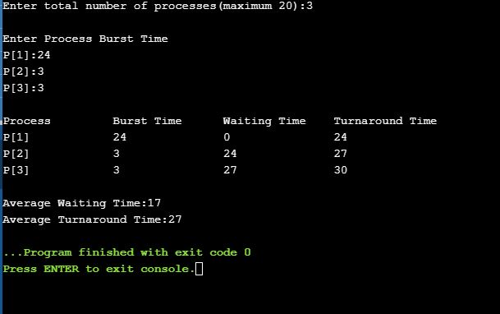

6. Write a program to implement First Come First Serve (FCFS) CPU Scheduling Algorithm with Arrival Time

#include<stdio.h>
int main()
{

int bt[10]={0},at[10]={0},tat[10]={0},wt[10]={0},ct[10]={0};
int n,sum=0;
float totalTAT=0,totalWT=0;

printf("Enter number of processes ");
scanf("%d",&n);

printf("Enter arrival time and burst time for each process\n\n");

for(int i=0;i<n;i++)
{

printf("Arrival time of process[%d] ",i+1);
scanf("%d",&at[i]);

printf("Burst time of process[%d] ",i+1);
scanf("%d",&bt[i]);

printf("\n");
}

//calculate completion time of processes

for(int j=0;j<n;j++)
{
sum+=bt[j];
ct[j]+=sum;
}

//calculate turnaround time and waiting times

for(int k=0;k<n;k++)
{
tat[k]=ct[k]-at[k];
totalTAT+=tat[k];
}

for(int k=0;k<n;k++)
{
wt[k]=tat[k]-bt[k];
totalWT+=wt[k];
}

printf("Solution: \n\n");
printf("P#\t AT\t BT\t CT\t TAT\t WT\t\n\n");

for(int i=0;i<n;i++)
{
printf("P%d\t %d\t %d\t %d\t %d\t %d\n",i+1,at[i],bt[i],ct[i],tat[i],wt[i]);
}

printf("\n\nAverage Turnaround Time = %f\n",totalTAT/n);
printf("Average WT = %f\n\n",totalWT/n);

return 0;
}

OUTPUT:-

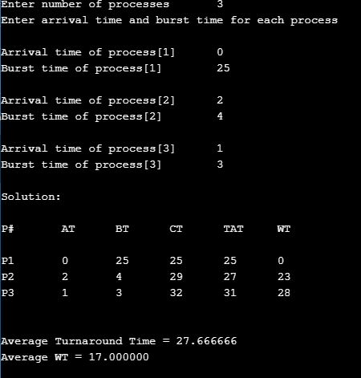
7. Write a program to implement Shortest Job First (SJF) CPU Scheduling Algorithm without arrival time.

#include<stdio.h>
void main()
{

int bt[20],p[20],wt[20],tat[20],i,j,n,total=0,pos,temp;
float avg_wt,avg_tat;
printf("Enter number of process:");
scanf("%d",&n);

printf("\nEnter Burst Time:\n");

for(i=0;i<n;i++)
{
printf("p%d:",i+1);
scanf("%d",&bt[i]);
p[i]=i+1; //contains process number
}

//sorting burst time in ascending order using selection sort

for(i=0;i<n;i++)
{
pos=i;
for(j=i+1;j<n;j++)
{
if(bt[j]<bt[pos])
pos=j;
}

temp=bt[i];
bt[i]=bt[pos];
bt[pos]=temp;

temp=p[i];
p[i]=p[pos];
p[pos]=temp;
}

wt[0]=0; //waiting time for first process will be zero

//calculate waiting time
for(i=1;i<n;i++)
{
wt[i]=0;
for(j=0;j<i;j++)
wt[i]+=bt[j];

total+=wt[i];
}

avg_wt=(float)total/n; //average waiting time
total=0;

printf("\nProcess\t Burst Time \tWaiting Time\tTurnaround Time");
for(i=0;i<n;i++)
{
tat[i]=bt[i]+wt[i]; //calculate turnaround time
total+=tat[i];
printf("\np%d\t\t %d\t\t %d\t\t\t%d",p[i],bt[i],wt[i],tat[i]);
}

avg_tat=(float)total/n; //average turnaround time
printf("\n\nAverage Waiting Time=%f",avg_wt);
printf("\nAverage Turnaround Time=%f\n",avg_tat);
}

OUTPUT:-

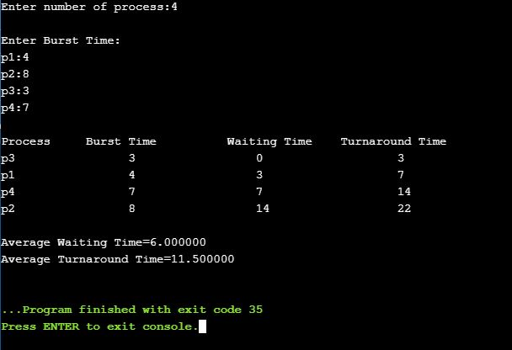

8. Write a program to implement Shortest Job First (SJF) CPU Scheduling Algorithm with arrival time

#include<stdio.h>
#include<conio.h>
#include<string.h>
void main()
{
int et[20],at[10],n,i,j,temp,st[10],ft[10],wt[10],ta[10];
int totwt=0,totta=0;
float awt,ata;
char pn[10][10],t[10];
//clrscr();
printf("Enter the number of process:");
scanf("%d",&n);

for(i=0; i<n; i++)
{
printf("Enter process name, arrival time& execution time:");
//flushall();
scanf("%s%d%d",pn[i],&at[i],&et[i]);
}

for(i=0; i<n; i++)
for(j=0; j<n; j++)
{
if(et[i]<et[j])
{
temp=at[i];
at[i]=at[j];
at[j]=temp;
temp=et[i];
et[i]=et[j];
et[j]=temp;
strcpy(t,pn[i]);
strcpy(pn[i],pn[j]);
strcpy(pn[j],t);
}
}

for(i=0; i<n; i++)
{
if(i==0)
st[i]=at[i];
else
st[i]=ft[i-1];

wt[i]=st[i]-at[i];
ft[i]=st[i]+et[i];
ta[i]=ft[i]-at[i];
totwt+=wt[i];
totta+=ta[i];
}

awt=(float)totwt/n;
ata=(float)totta/n;
printf("\nPname\tarrivaltime\texecutiontime\twaitingtime\ttatime");

for(i=0; i<n; i++)
printf("\n%s\t%5d\t\t%5d\t\t%5d\t\t%5d",pn[i],at[i],et[i],wt[i],ta[i]);
printf("\nAverage waiting time is:%f",awt);
printf("\nAverage turnaroundtime is:%f",ata);
getch();
}

OUTPUT:-

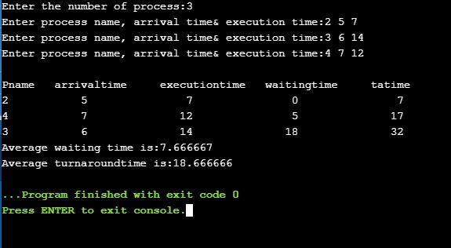

9. Write a program to implement Shortest Remaining Time First (SRTF) CPU Scheduling Algorithm.

#include <stdio.h>
int main()
{
int a[10],b[10],x[10],i,j,smallest,count=0,time,n;
double avg=0,tt=0,end;
printf("enter the number of Processes:\n");
scanf("%d",&n);
printf("enter arrival time\n");

for(i=0;i<n;i++)
scanf("%d",&a[i]);
printf("enter burst time\n");

for(i=0;i<n;i++)
scanf("%d",&b[i]);

for(i=0;i<n;i++)
x[i]=b[i];

b[9]=9999;

for(time=0;count!=n;time++)
{
smallest=9;

for(i=0;i<n;i++)
{
if(a[i]<=time && b[i]<b[smallest] && b[i]>0 )
smallest=i;
}
b[smallest]--;
if(b[smallest]==0)
{
count++;
end=time+1;
avg=avg+end-a[smallest]-x[smallest];
tt= tt+end-a[smallest];
}
}
printf("\n\nAverage waiting time = %lf\n",avg/n);
printf("Average Turnaround time = %lf",tt/n);
return 0;
}

OUTPUT:-

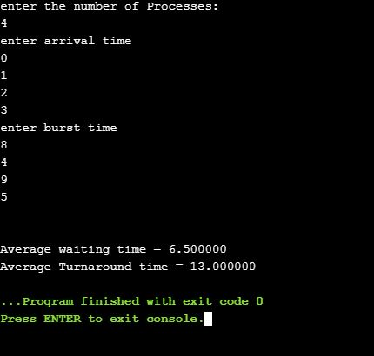

10. Write a program to implement Priority CPU Scheduling Algorithm without arrival time

#include<stdio.h>
// Function to find the waiting time for all
// processes
void findWaitingTime(int processes[], int n,
int bt[], int wt[])
{
// waiting time for first process is 0
wt[0] = 0;

// calculating waiting time
for (int i = 1; i < n ; i++ )
wt[i] = bt[i-1] + wt[i-1] ;
}

// Function to calculate turn around time
void findTurnAroundTime( int processes[], int n,
int bt[], int wt[], int tat[])
{
// calculating turnaround time by adding
// bt[i] + wt[i]
for (int i = 0; i < n ; i++)
tat[i] = bt[i] + wt[i];
}

//Function to calculate average time
void findavgTime( int processes[], int n, int bt[])
{
int wt[n], tat[n], total_wt = 0, total_tat = 0;

//Function to find waiting time of all processes
findWaitingTime(processes, n, bt, wt);

//Function to find turn around time for all processes
findTurnAroundTime(processes, n, bt, wt, tat);

//Display processes along with all details
printf("Processes Burst time Waiting time Turn around time\n");

// Calculate total waiting time and total turn
// around time
for (int i=0; i<n; i++)
{
total_wt = total_wt + wt[i];
total_tat = total_tat + tat[i];
printf(" %d ",(i+1));
printf(" %d ", bt[i] );
printf(" %d",wt[i] );
printf(" %d\n",tat[i] );
}
int s=(float)total_wt / (float)n;
int t=(float)total_tat / (float)n;
printf("Average waiting time = %d",s);
printf("\n");
printf("Average turn around time = %d ",t);
}

// Driver code
int main()
{
//process id's
int processes[] = { 1, 2, 3};
int n = sizeof processes / sizeof processes[0];

//Burst time of all processes
int burst_time[] = {10, 5, 8};

findavgTime(processes, n, burst_time);
return 0;
}

OUTPUT:-

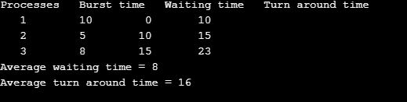

11. WRITE A PROGRAM TO IMPLEMENT PRIORITY CPU SCHEDULING ALOGORITHM WITH ARRIVAL TIME.

#include<stdio.h>
int main()
{
int bt[20],p[20],wt[20],tat[20],pr[20],i,j,n,total=0,pos,temp,avg_wt,avg_tat;
printf("Enter Total Number of Process:");
scanf("%d",&n);

printf("\nEnter Burst Time and Priority\n");
for(i=0;i<n;i++)
{
printf("\nP[%d]\n",i+1);
printf("Burst Time:");
scanf("%d",&bt[i]);
printf("Priority:");
scanf("%d",&pr[i]);
p[i]=i+1; //contains process number
}

//sorting burst time, priority and process number in ascending order using selection sort
for(i=0;i<n;i++)
{
pos=i;
for(j=i+1;j<n;j++)
{
if(pr[j]<pr[pos])
pos=j;
}

temp=pr[i];
pr[i]=pr[pos];
pr[pos]=temp;

temp=bt[i];
bt[i]=bt[pos];
bt[pos]=temp;

temp=p[i];
p[i]=p[pos];
p[pos]=temp;
}

wt[0]=0; //waiting time for first process is zero

//calculate waiting time
for(i=1;i<n;i++)
{
wt[i]=0;
for(j=0;j<i;j++)
wt[i]+=bt[j];

total+=wt[i];
}

avg_wt=total/n; //average waiting time
total=0;

printf("\nProcess\t Burst Time \tWaiting Time\tTurnaround Time");
for(i=0;i<n;i++)
{
tat[i]=bt[i]+wt[i]; //calculate turnaround time
total+=tat[i];
printf("\nP[%d]\t\t %d\t\t %d\t\t\t%d",p[i],bt[i],wt[i],tat[i]);
}

avg_tat=total/n; //average turnaround time
printf("\n\nAverage Waiting Time=%d",avg_wt);
printf("\nAverage Turnaround Time=%d\n",avg_tat);

return 0;
}

OUTPUT:-

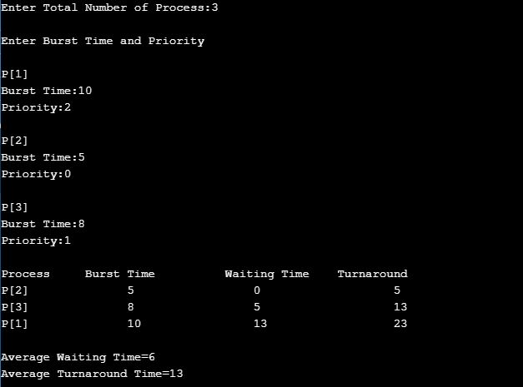

12. WRITE A PROGRAM TO IMPLEMENT ROUND ROBIN(RR) CPU SCHEDULING ALGORITHM.

#include<stdio.h>
int main()
{

int count,j,n,time,remain,flag=0,time_quantum;
int wait_time=0,turnaround_time=0,at[10],bt[10],rt[10];
printf("Enter Total Process:\t ");
scanf("%d",&n);
remain=n;

for(count=0;count<n;count++)
{
printf("Enter Arrival Time and Burst Time for Process Process Number %d :",count+1);
scanf("%d",&at[count]);
scanf("%d",&bt[count]);
rt[count]=bt[count];
}

printf("Enter Time Quantum:\t");
scanf("%d",&time_quantum);
printf("\n\nProcess\t|Turnaround Time|Waiting Time\n\n");

for(time=0,count=0;remain!=0;)
{
if(rt[count]<=time_quantum && rt[count]>0)
{
time+=rt[count];
rt[count]=0;
flag=1;
}
else if(rt[count]>0)
{
rt[count]-=time_quantum;
time+=time_quantum;
}
if(rt[count]==0 && flag==1)
{
remain--;
printf("P[%d]\t|\t%d\t|\t%d\n",count+1,time-at[count],time-at[count]-bt[count]);
wait_time+=time-at[count]-bt[count];
turnaround_time+=time-at[count];
flag=0;
}

if(count==n-1)
count=0;
else if(at[count+1]<=time)
count++;
else
count=0;
}
printf("\nAverage Waiting Time= %f\n",wait_time*1.0/n);
printf("Avg Turnaround Time = %f",turnaround_time*1.0/n);

return 0;
}

OUTPUT:-

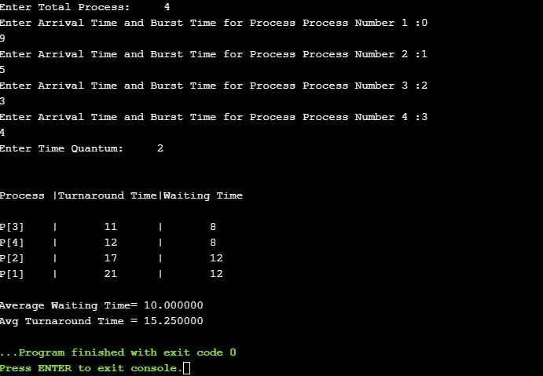

13. WRITE A PROGRAM TO IMPLEMENT PRODUCER-CONSUMER PROBLEM USING SIMPLE QUEUE.

#include<stdio.h>
#include<stdlib.h>

int mutex=1,full=0,empty=3,x=0;

int main()
{
int n;
void producer();
void consumer();
int wait(int);
int signal(int);
printf("\n1.Producer\n2.Consumer\n3.Exit");
while(1)
{
printf("\nEnter your choice:");
scanf("%d",&n);
switch(n)
{
case 1: if((mutex==1)&&(empty!=0))
producer();
else
printf("Buffer is full!!");
break;
case 2: if((mutex==1)&&(full!=0))
consumer();
else
printf("Buffer is empty!!");
break;
case 3:
exit(0);
break;
}
}

return 0;
}

int wait(int s)
{
return (--s);
}

int signal(int s)
{
return(++s);
}

void producer()
{
mutex=wait(mutex);
full=signal(full);
empty=wait(empty);
x++;
printf("\nProducer produces the item %d",x);
mutex=signal(mutex);
}

void consumer()
{
mutex=wait(mutex);
full=wait(full);
empty=signal(empty);
printf("\nConsumer consumes item %d",x);
x--;
mutex=signal(mutex);
}

OUTPUT:-

